Lance Antonio, Shreekrishna Sapkota, Binit Banjara, Aaditya Garg

Abstract

This document is a compilation of all system specifications relating to the event-booking system developed for Event Master. It will tackle different components of the system that are used for it’s development.

Mid-project deliverables

Event Master developed by ProIT

# Section 1: System requirements traceability

## Functional Requirements

Outlined below are the different functional requirement that have been identified for the system being developed.

|  |  |  |  |
| --- | --- | --- | --- |
| **No.** | **Functional Requirement** | **Components File Name** | **Comments / Description** |
| FR1 | Client User Registration | Registration.php | The customers should be able to register in order to access the full booking management service of the system |
| FR2 | Client User Login | Home.php | Existing customers should be able to login to the website using their registered login details. |
| FR3 | Client User Logout | User-Dashboard.php | The customers logged in to the website should be able to logout of their accounts. |
| FR4 | Client User Forgot Password | Forgot-Password.php | The customers should have the option to reset their password in the event that they are unable to login using their current login details. |
| FR5 | Update Client User Details | User-Details.php | The customers should be able to edit their personal details should they need to. |
| FR6 | Client User Event Booking | Event-Booking.php | The customers should have the ability to book their events in the system and include all the data related to their events such as time, date, event type, and equipment needed. |
| FR7 | Client User Manage Booking | manage-booking.php | The customer should be able to edit their booking specifics or add additional details after the initial booking. |
| FR8 | Event Type Selection | Event-Booking.php | The customers should be able to select from multiple event types to suit their needs. |
| FR9 | Client User Admin Contact | Query.php | The client user should have a way to contact the admin should they have any issue or need any assistance on any of their events. |
| FR10 | Event Status | User-Dashboard.php | Events should have a status of Active / Closed so that customers would be able to filter out or be able to view their previous events. |
| FR11 | Multiple Event Booking | User-Dashboard.php | The customers should be able to book more than one event. |
| FR12 | Admin User Dashboard | Admin-Dashboard.php | The admin user should have a dashboard page that would outline the different statistics within the system. |
| FR13 | Admin User Statistical Data | Admin-Dashboard.php | The admin user should be able to view live data statistics from the database such as such as client count, active events, closed events. |
| FR14 | Admin User Update Event Details | Manage-Booking.php | The admin user should be able to change the details of any customer event so they may be able to update the details for the customer if requested or if any correction is needed. |
| FR15 | Admin User Archive View | Archive-View.php | The admin user should be able to view historical data of events that have already been done. |
| FR16 | Admin User Event Catalog View | Event-View.php | The admin user should be able to view all of the different event types, edit, and add into it. |
| FR17 | Admin User Customer View | Customer-View.php | The admin user should have a dashboard of all the existing customers to be able to perform a search function on it. |
| FR18 | Admin User Active Events View | Active-View.php | The admin user should have a dashboard of all the active events, or events that have not yet taken place. |
| FR19 | Admin User Reply | Query.php | The admin user should be able to reply to client user queries made through the system. |
| FR20 | Admin User Registration | Registration.php | The admin user should be able to create another admin user in case there is a need for another admin access within the organization. |

Figure 1: Functional Requirements

## Non-Functional Requirements

Outlined below are the different functional requirement that have been identified for the system being developed.

|  |  |  |
| --- | --- | --- |
| **No.** | **Non-Functional Requirement** | **Comments / Description** |
| NFR1 | Security | * Strong password requirement for users. (8 Minimum Characters, with 1 Numerical) * MD5 Security to be implemented for secure data storage and retrieval. |
| NFR2 | Availability | * 24/7 access availability on the webpage to allow for customers to be able to gain access whenever they need. |
| NFR3 | Performance | * Maximizing the responsiveness of the website my optimizing and compressing images, and choosing a performance-optimized hosting solution(Amazon Web Services). |
| NFR4 | Reliability | * The webpage will be utilizing Amazon Web Services to increase security, and more importantly, to ensure that the website is able to handle large volume of customers all at the same time. |
| NFR5 | Accessibility | * The webpage will be developed to be accessible via multiple devices, namely mobile, tablets, and laptops for a responsive web design. * The webpage’s design will allow for an easy to use user interface and visually appealing. |
| NFR6 | Scalability | * Through the use of Amazon Web Services, the website will be able to handle large amounts of users all at the same time and will be easy to increase the storage capacity needs of the site depending on the increase of the customers over time. |
| NFR7 | Useability | * The team will work towards a visually appealing and easy to navigate webpage design. The aim is to ensure all relevant information is easy to find for the customers and the ensure that the customers will have an easy time navigating through the whole webpage. |

Figure 2: Non-Functional Requirement

# Section 2: System Architecture

## 2.1 System Overview

Event Master is a web-based online booking system which enables its users to check availabilities, book, manage, and update information about their events. This is created to streamline the manual process of event booking which the company is currently using. The system is developed using the combination of applications such as HTML, PHP, and MySQL.

## 2.2 System Architecture Overview

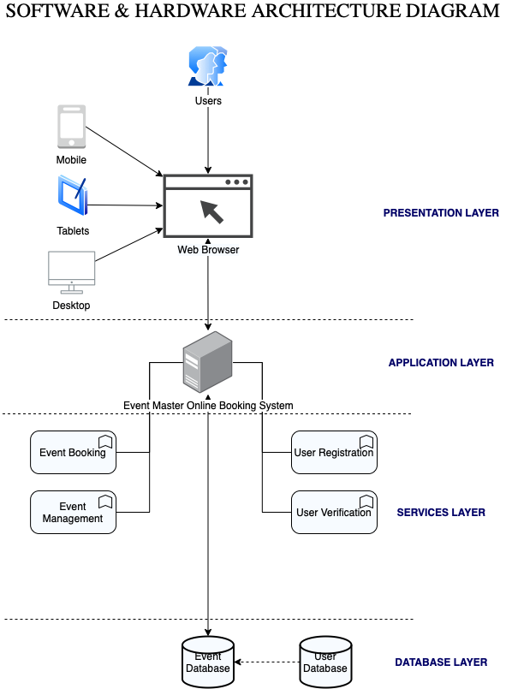

Figure 3: Software and Hardware Architecture Diagram

The architecture of the Event Master’s webpage will start from it’s users’ access to the website by the use of their devices. These devices, such as mobile, tablets, or desktop will then use a web browser application to access which will prompt either a login or a registration. Once access has been granted, users can then access the different services that it offers such as the event booking, and event management functionalities. This front-end is connected to the system’s database through the use of HTML, PHP and mySQL integration within the codes. The database receives, stores and retrieves the different user and event data relevant to the user access. Access to the system’s functionality and data is restricted depending on the user type and credentials.

## 2.3 Hardware component

**Monitor**: It is one of the most frequent and crucial hardware components. It's used to look at visuals, content, and the UI. As per the technical specifications, a monitor of at least 15 inches is preferred for a more efficient and suitable view.

**Processor**: We're running on a 3.0 GHz dual-core processor. Because processor and clock speed are the most crucial factors for improved computing capacity and easy on settings. As a result, it will be perfect for the system. The main function of the processor is to transfer data and carry out the requests made by the customer in the system, which is ideal for the platform to function properly.

**RAM**: It is Random Access Memory. For the proper operation of the system, it should be higher in size as well. Thus, we are selecting 512 MB.

**Hard** **Disk**: It is the computer's storage. Because our system will include more graphics and images we are using 400GB HDD which will be suffice to keep the machine running well.

## 2.4 Software Component

**Operating** **System**: Windows is the most cost-effective and user-friendly operating system. Our system is easier to expand and more flexible with Windows. As a result, we are running Windows like Windows XP, Windows 7, Windows 8, Windows 10.

**Browser**: The system can only be operated on the latest version of the Google Chrome as per the system requirement.

## 2.4.1 Web Server and Database-Used Content management

The web host in our software is APACHE, while the database server is MySQL. XAMPP, on the other hand, allows us to use the system to keep a connection on both the front and back-end. When the system is hosted at localhost, APACHE and MYSQL servers are running. After that, the XAMPP Control Panel, APACHE, and MySQL servers operate.

## 2.5 Logical View of the Systems

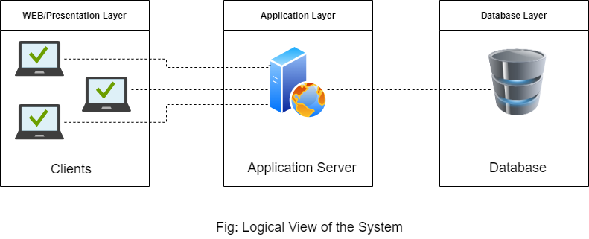

Figure 4: Logical View of the System

The above diagram shows the logical view of the Event master system. It is composed of three different layers, namely WEB/Presentation layer, Application layer, and Database Layer.

* WEB/Presentation layer: This layer is where most of the data are processed before interacting with the system. It is developed using html, CSS, and JavaScript.
* Application layer: In this layer, the clients interact with the system. It is also regarded as the connection between application layer and a database layer. In order to interact with the database layer and a presentation layer, a connection has been made using PHP. Client users will interact with this layer to book their events and manage their event details.
* Database layer: This is the layer where all the information inserted from the frontend are stored and we can easily fetch the data as per our requirement. This will contain all of the user data such as their current and past events, their existing queries, and

## 2.6 Functional View of System by Components

### 2.6.1 Registration

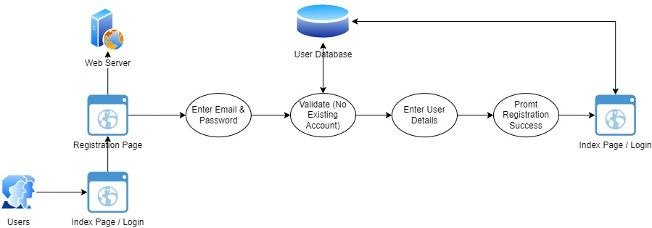

Figure 5: Registration

### 2.6.2 Home (Login & Logout)

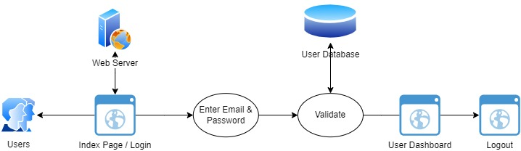

Figure 6: Home Page

### 2.6.3 Forgot Password

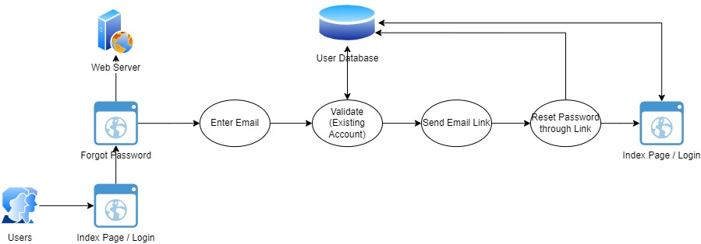

Figure 7: Forgot Password

### 2.6.4 User Details

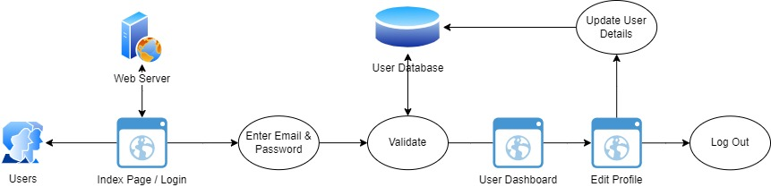

Figure 8: User Details

### 2.6.5 Event Booking

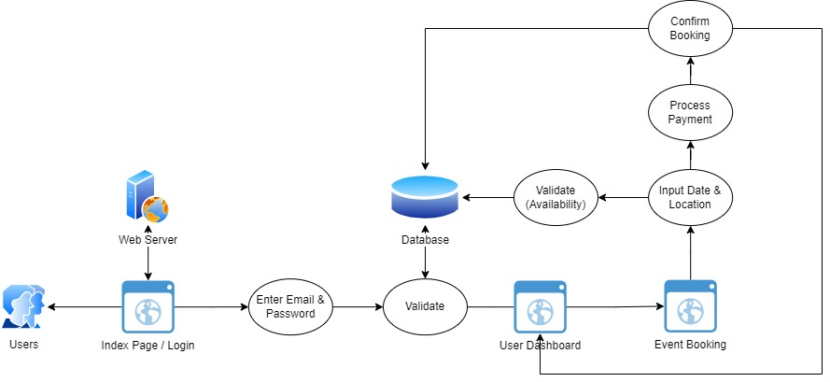

Figure 9: Event Booking

### 2.6.6 Manage Booking

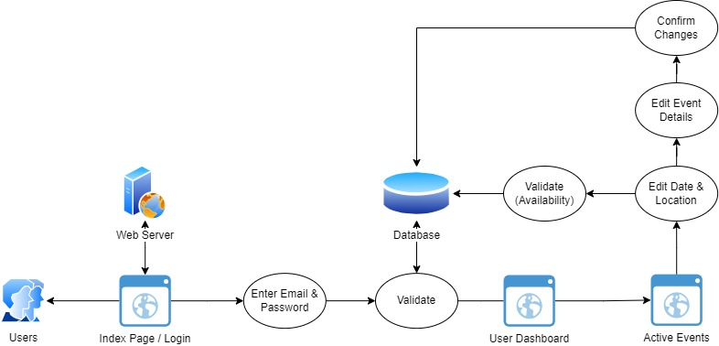

Figure 10: Manage Booking

### 2.6.7 Client User Query

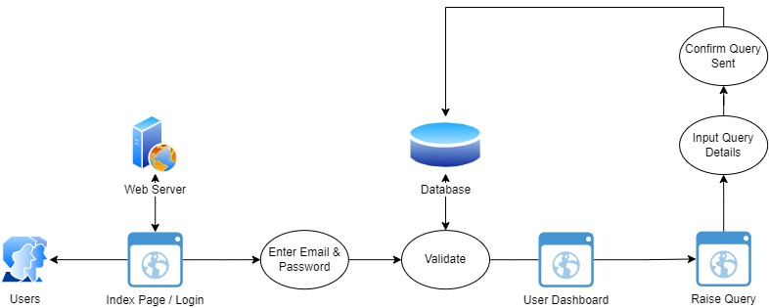

Figure 11: User Query

### 2.6.8 User & Admin Dashboard

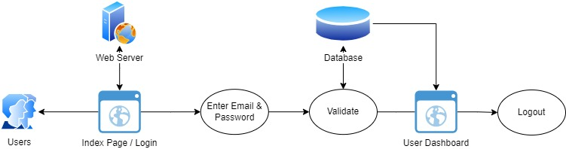

Figure 12: User & Admin Dashboard

### 2.6.10 Archive View

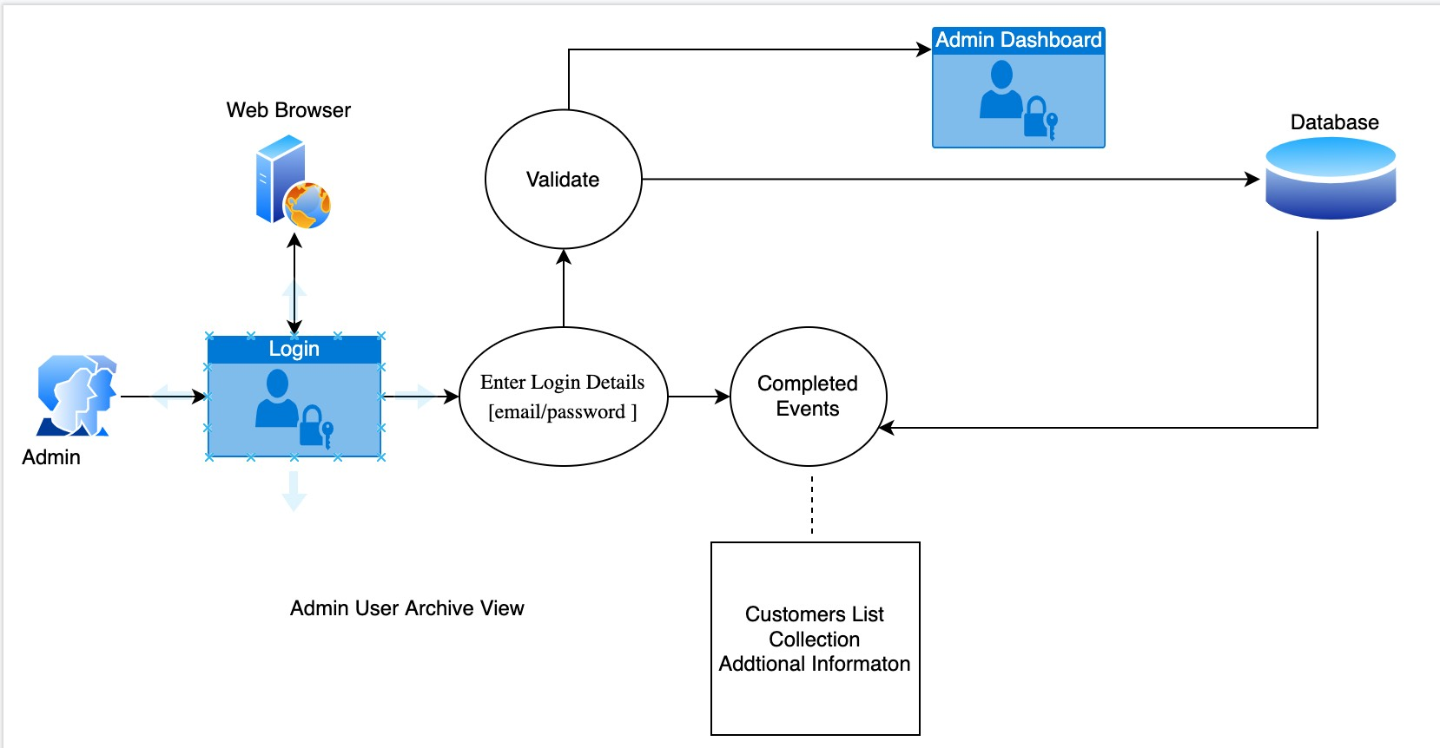

### 2.6.11 Event View

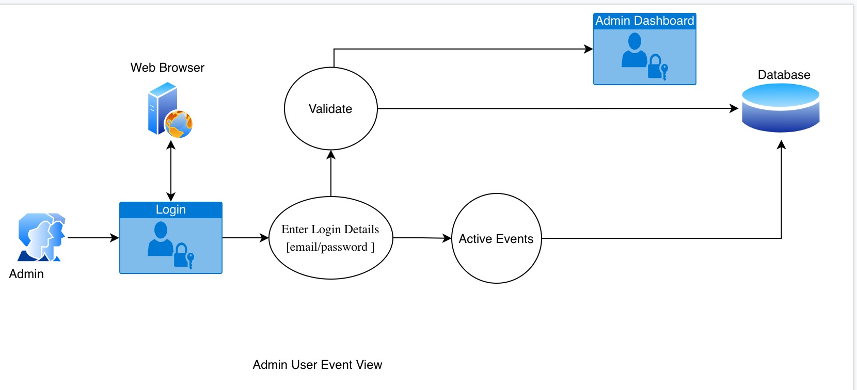

### 2.6.12 Customer View

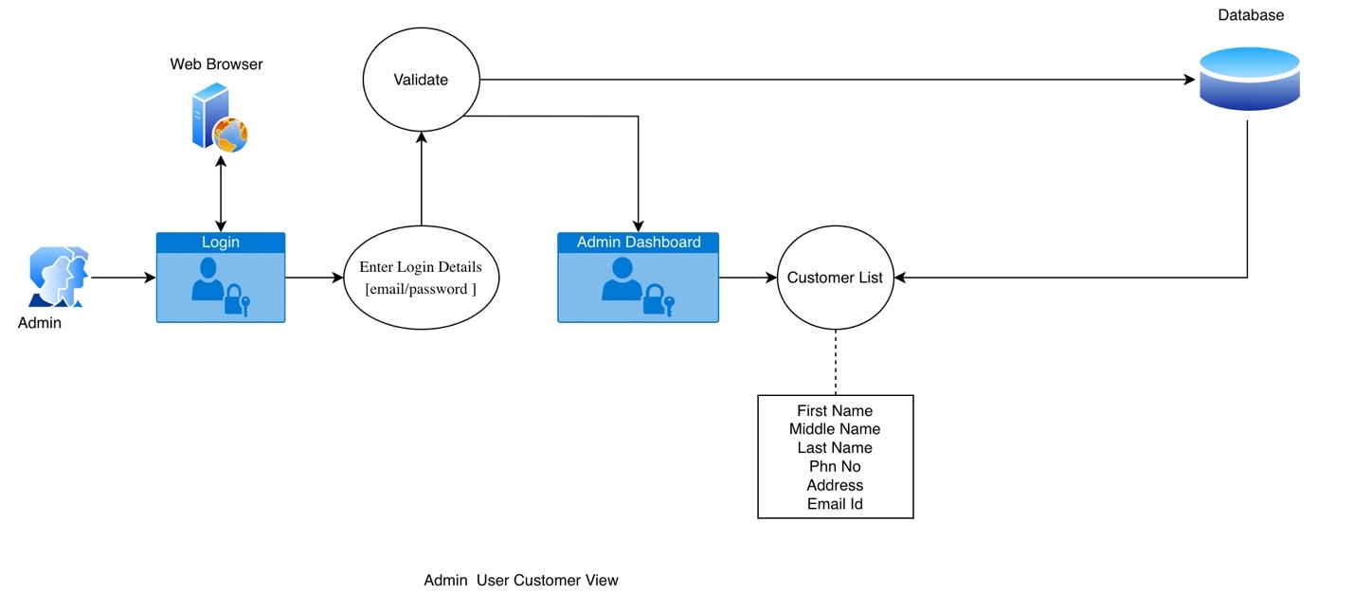

### 2.6.13 Active Events View

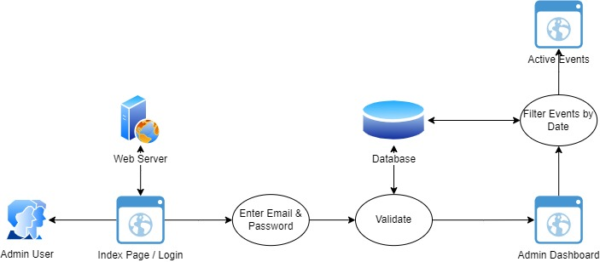

Figure 13: Active Events View

### 2.6.14 Admin User Query

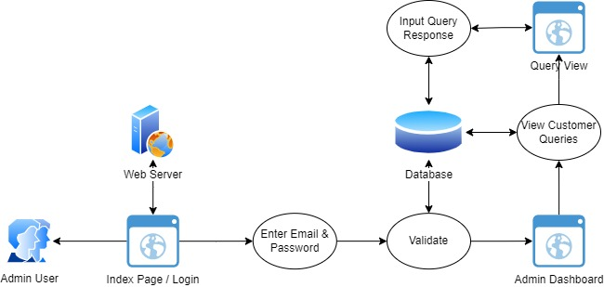

Figure 14: Admin User Query

# Section 3: Database design

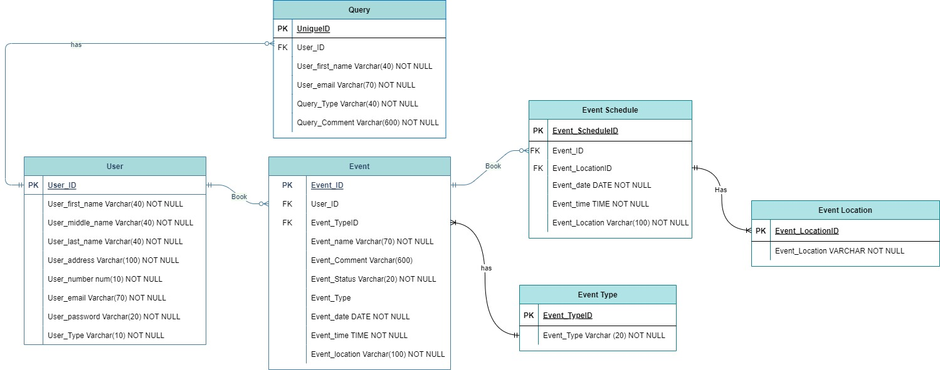

Figure 15: Entity-Relationship Diagram

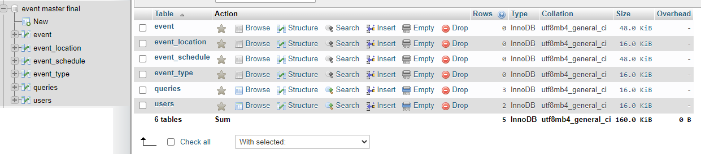

Figure 16: Event Master Entities

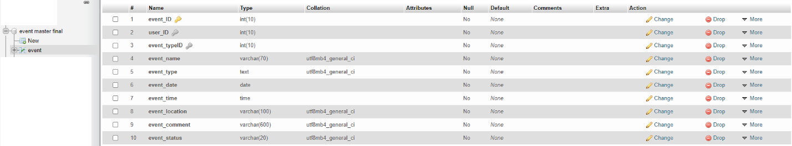

Figure 17: Event Entity



Figure 18:Event_Location Entity

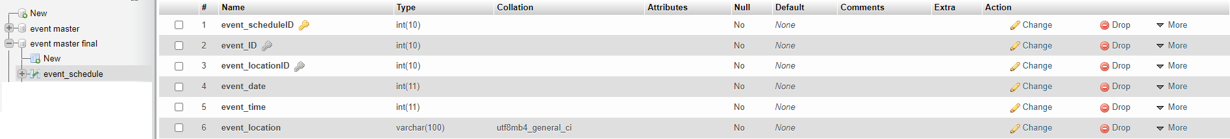

Figure 19: Event-Schedule Entity



Figure 20: Event-Type Entity

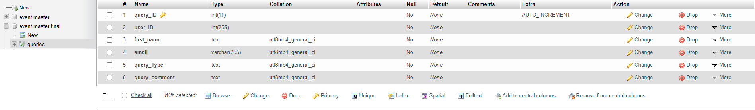

Figure 21:Queries Entity

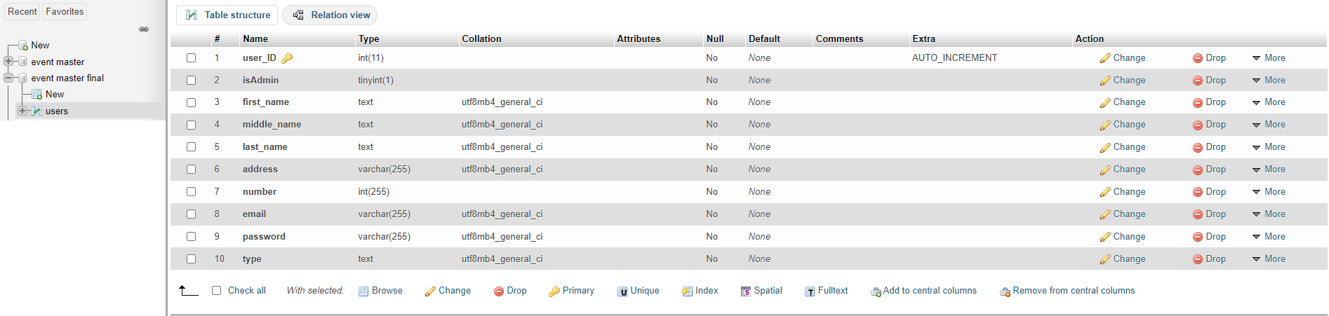

Figure 22: Users Entity

# Section 4: User Interfaces

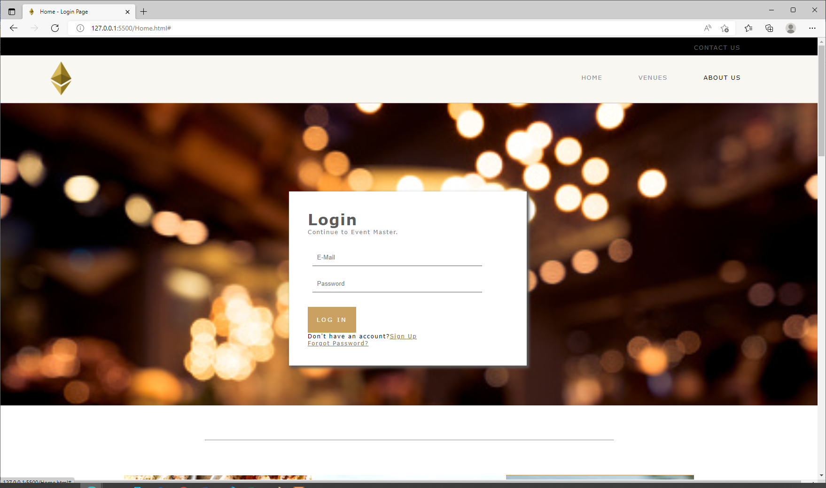

Figure 23:Home Page PC UI

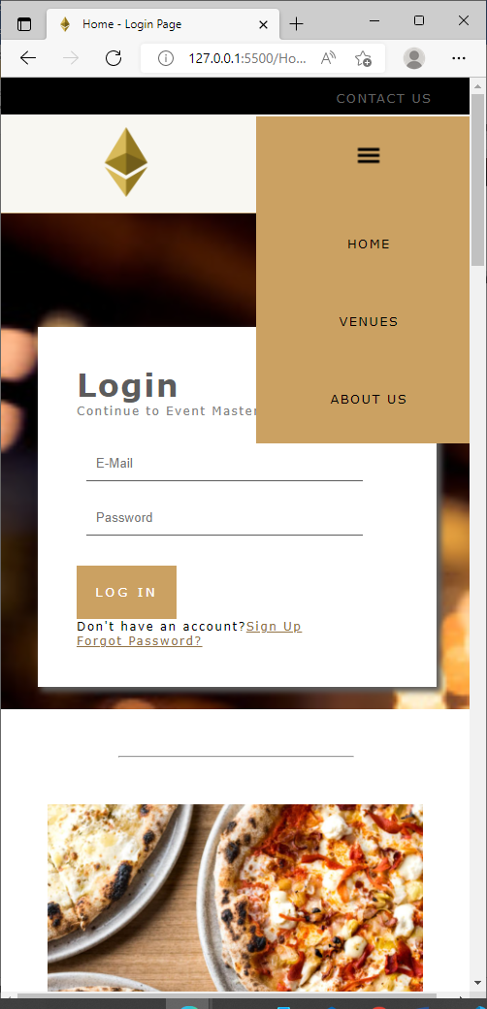

Figure 24: Home Page Mobile UI

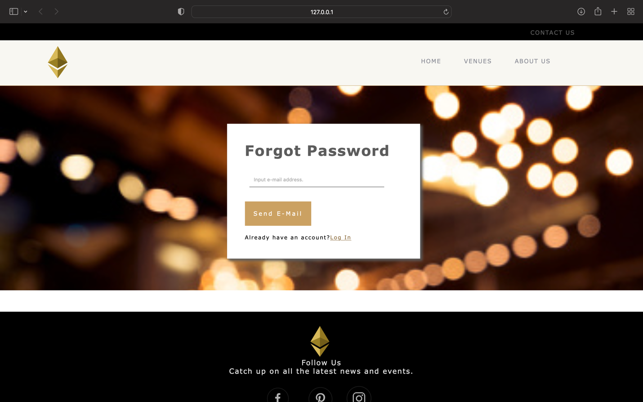

Figure 25: Forgot Password UI

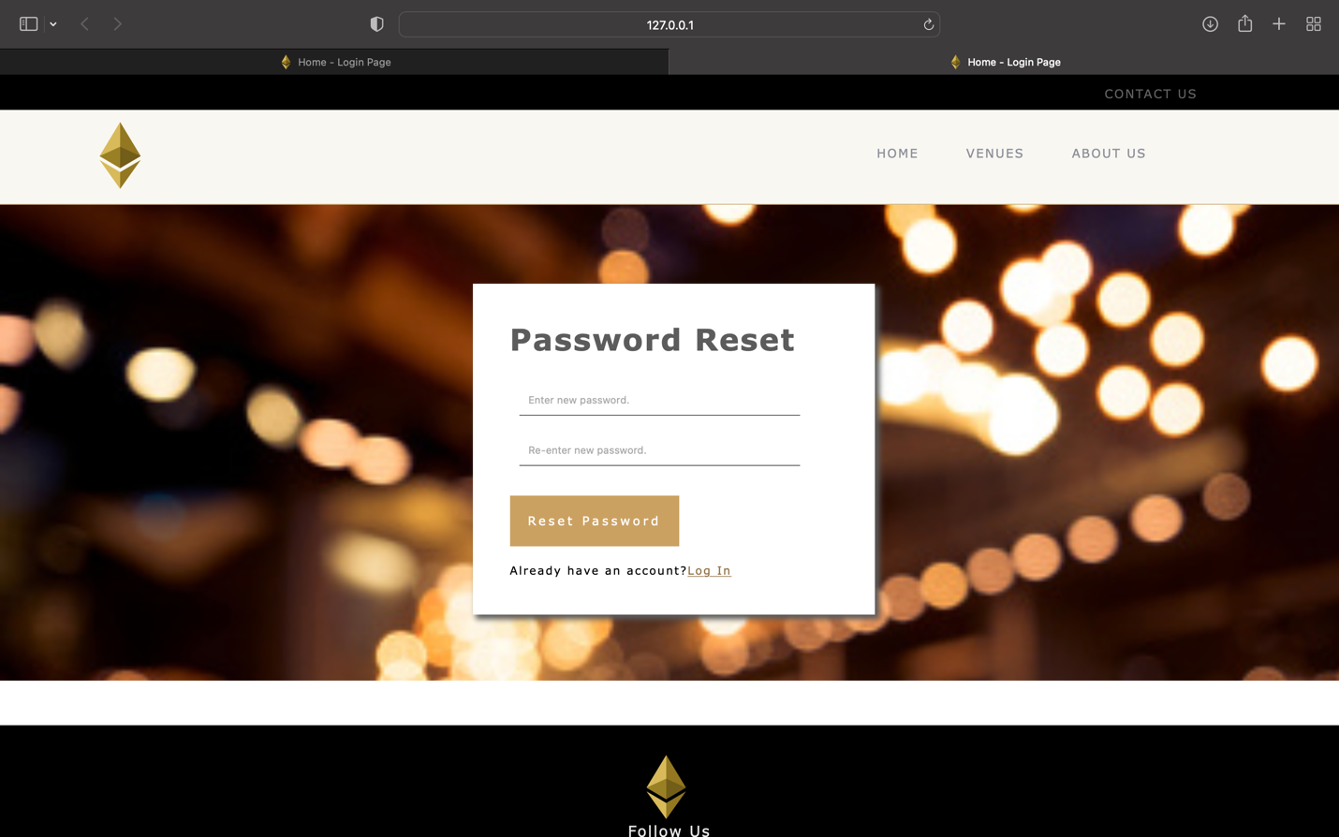

Figure 26: Password Reset UI

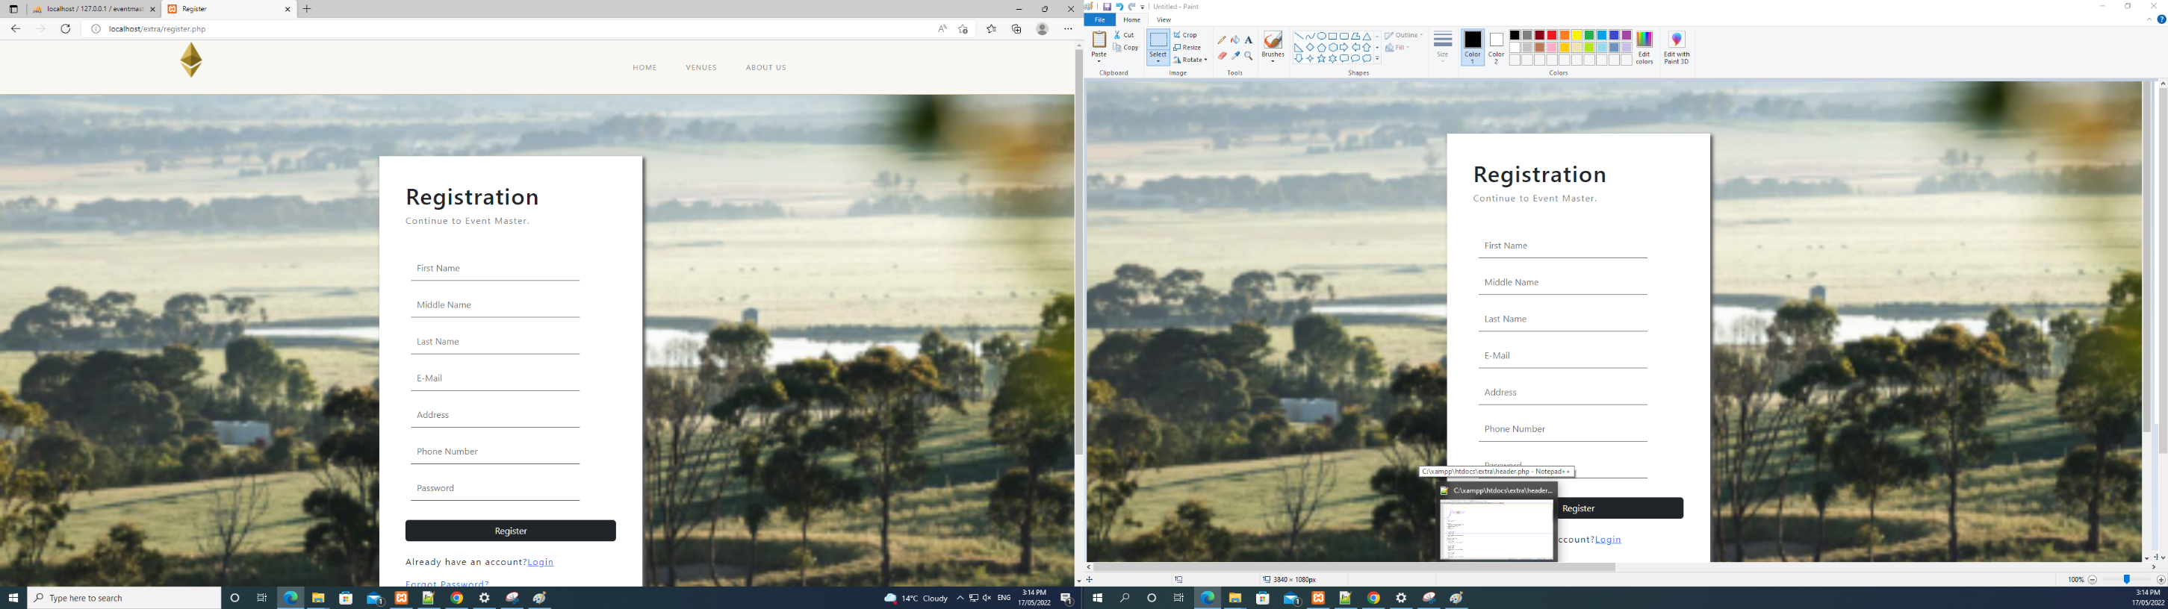

Figure 27: Registration Page UI

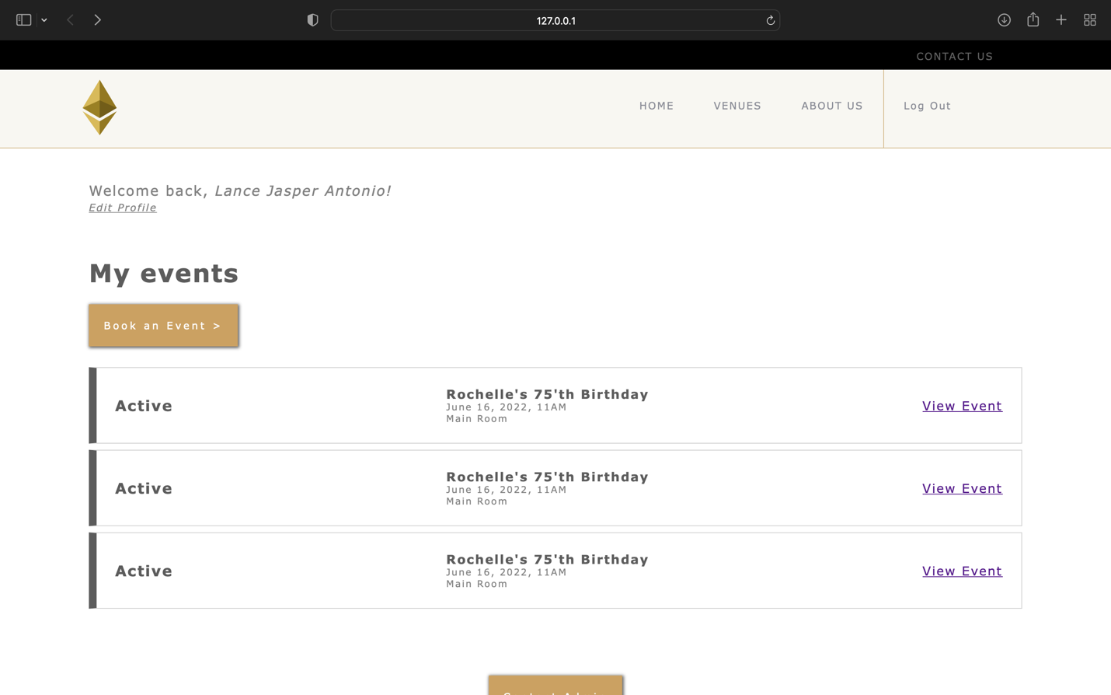

Figure 28: User Dashboard UI

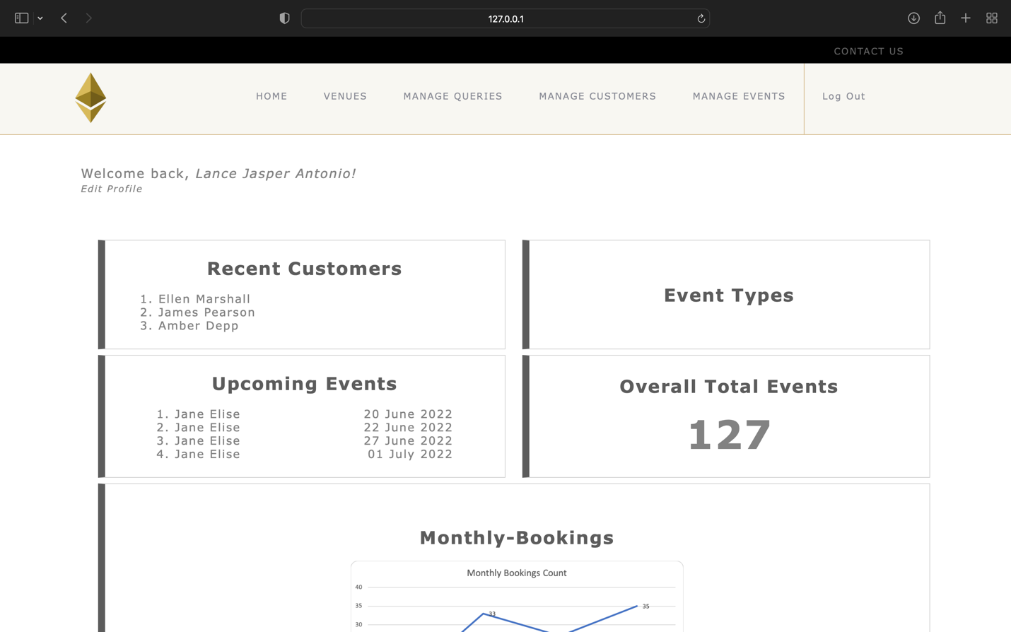

Figure 29: Admin Dashboard UI

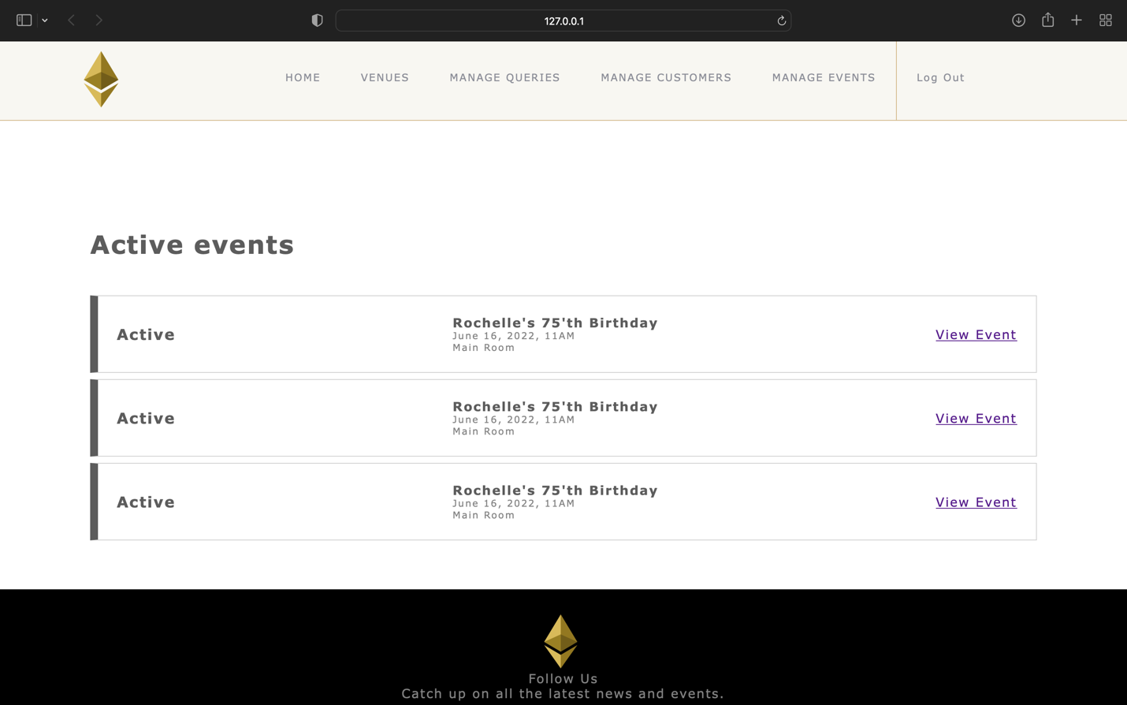

Figure 30: Active Event View UI

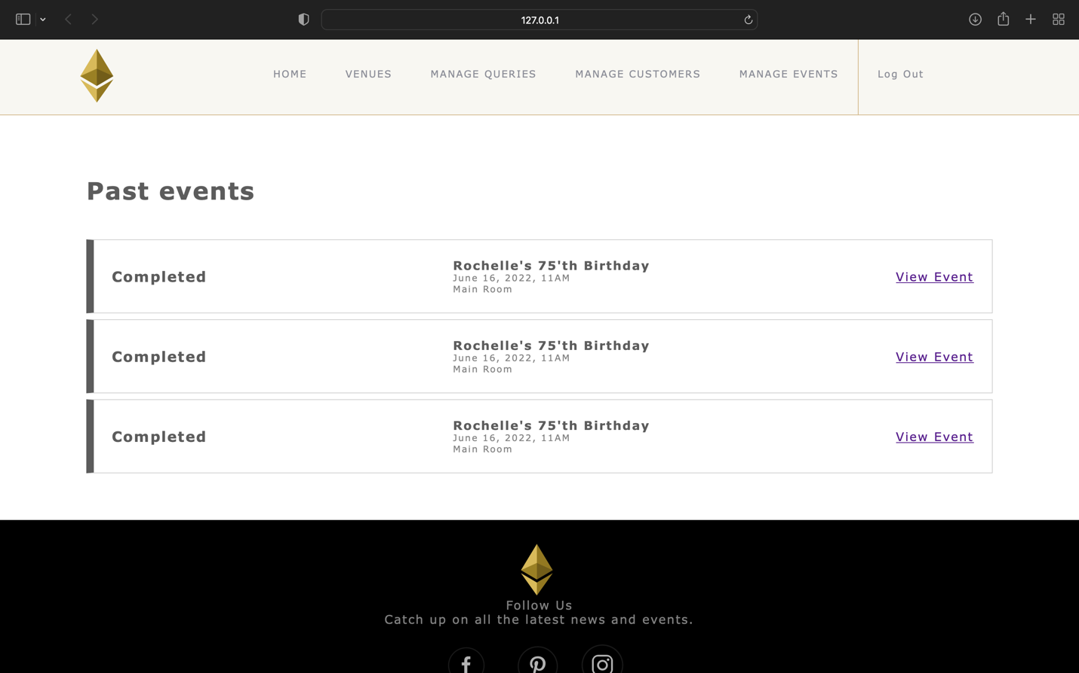

Figure 31: Archive View UI

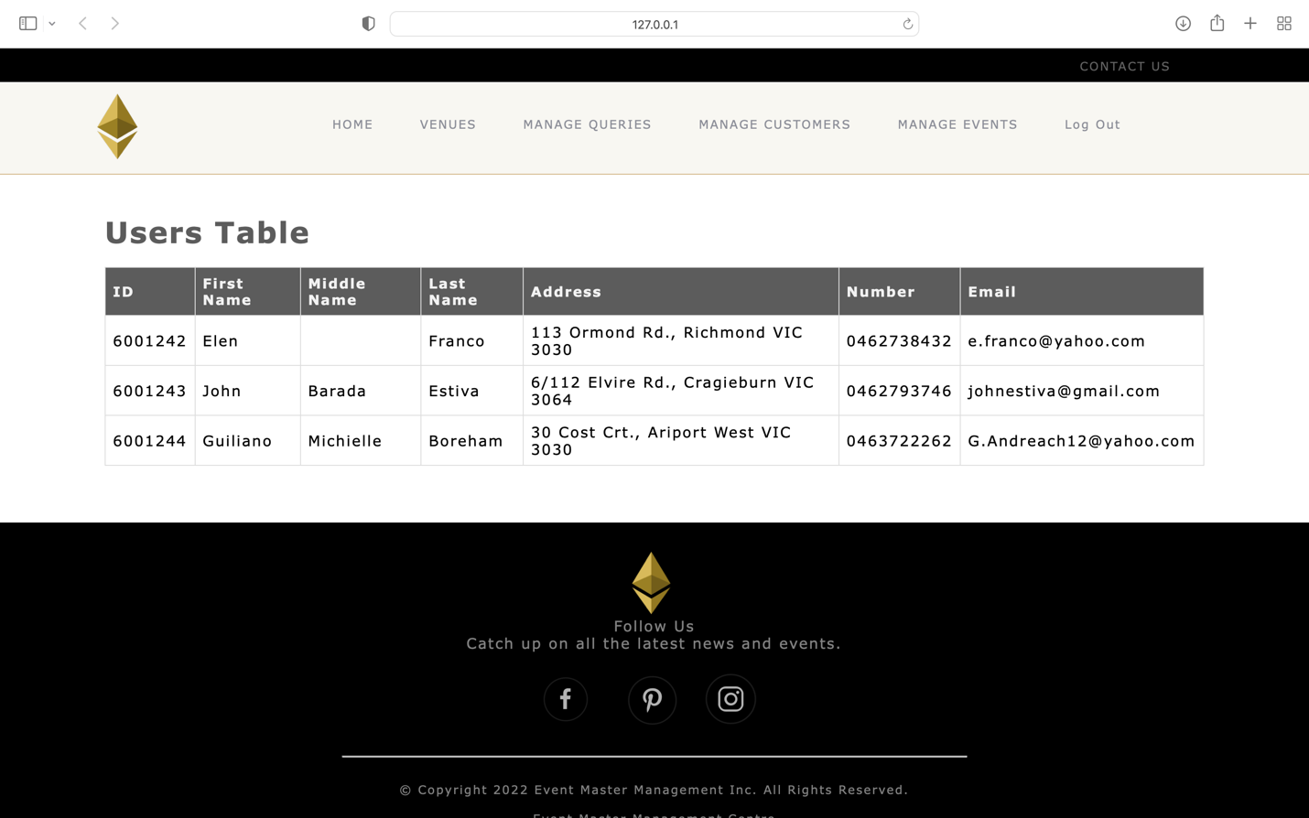

Figure 32: Users View UI

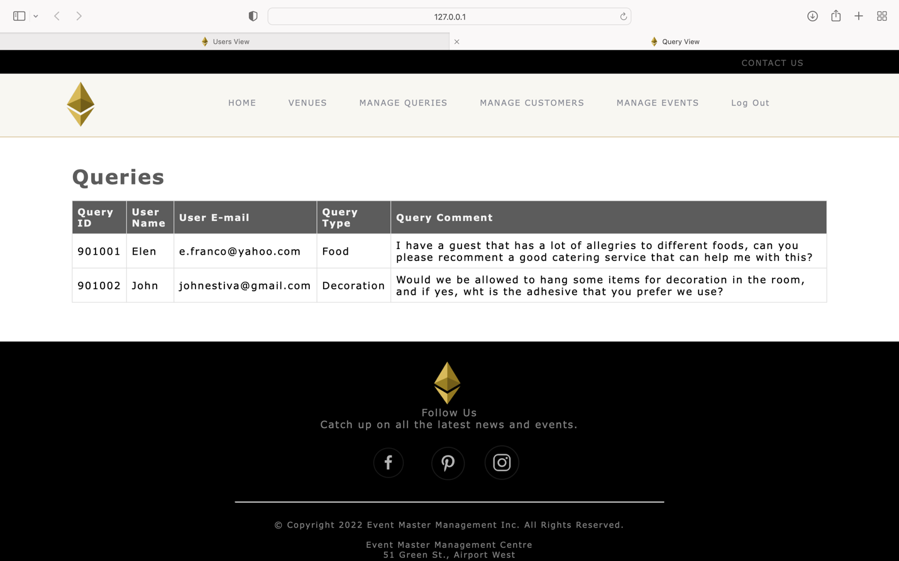

Figure 33: Queries View UI

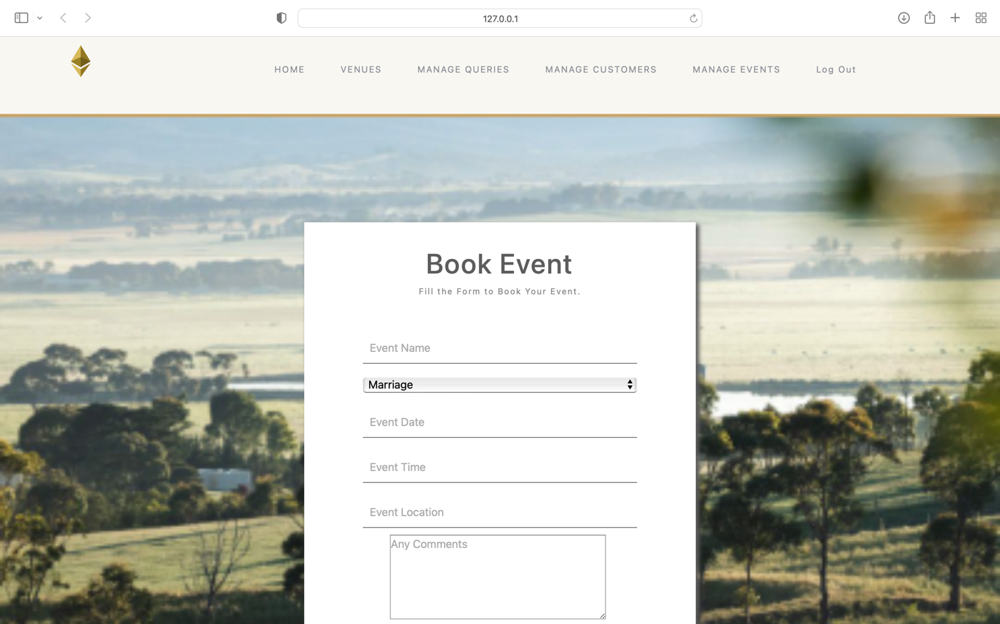

Figure 34: Event Booking UI

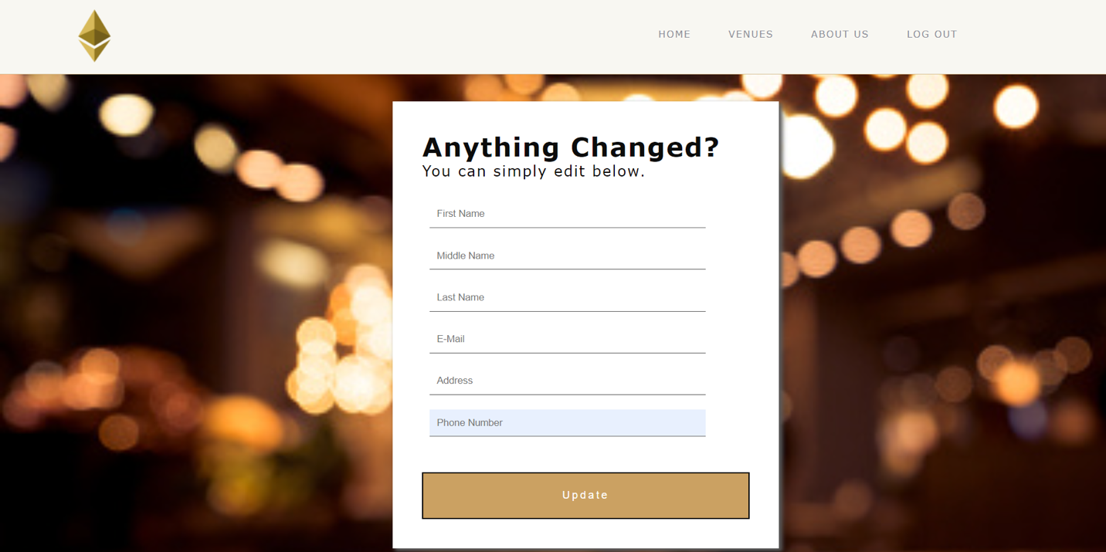

Figure 35: Update User Details UI

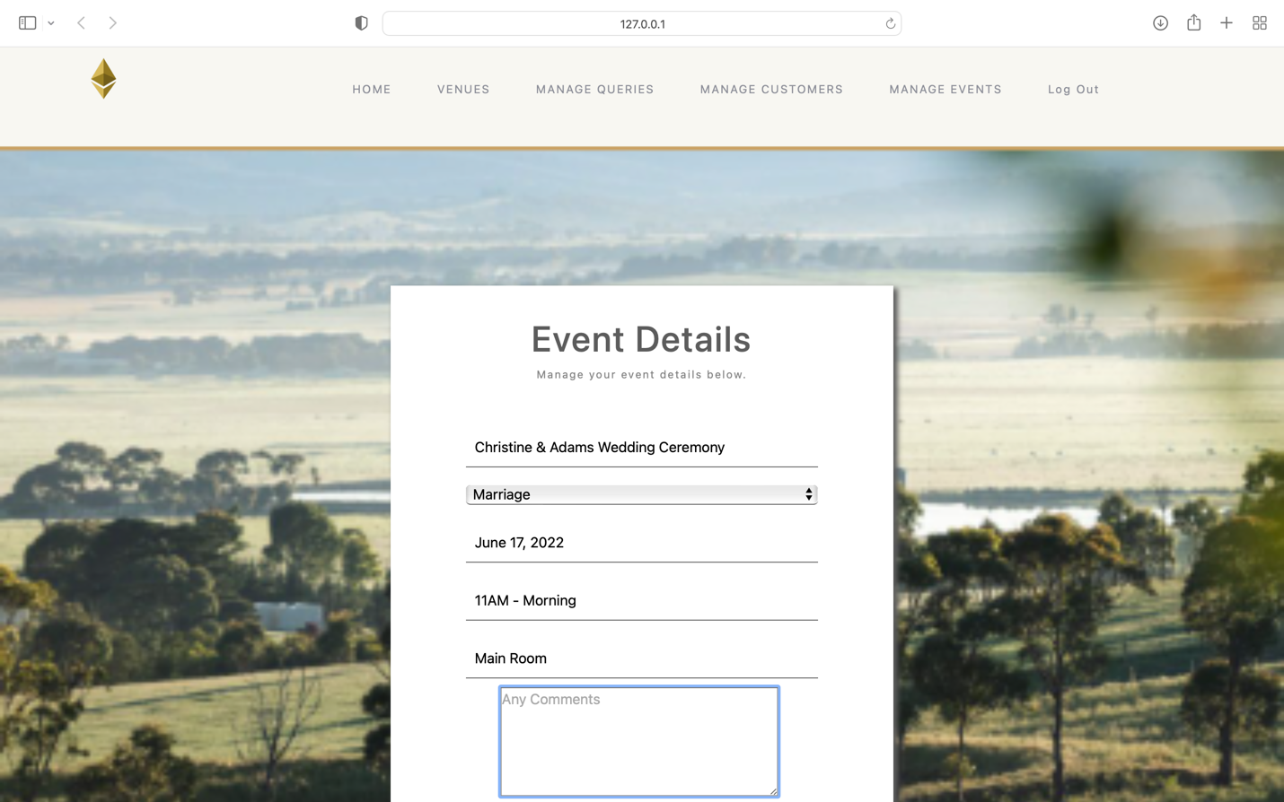

Figure 36: Manage Event UI

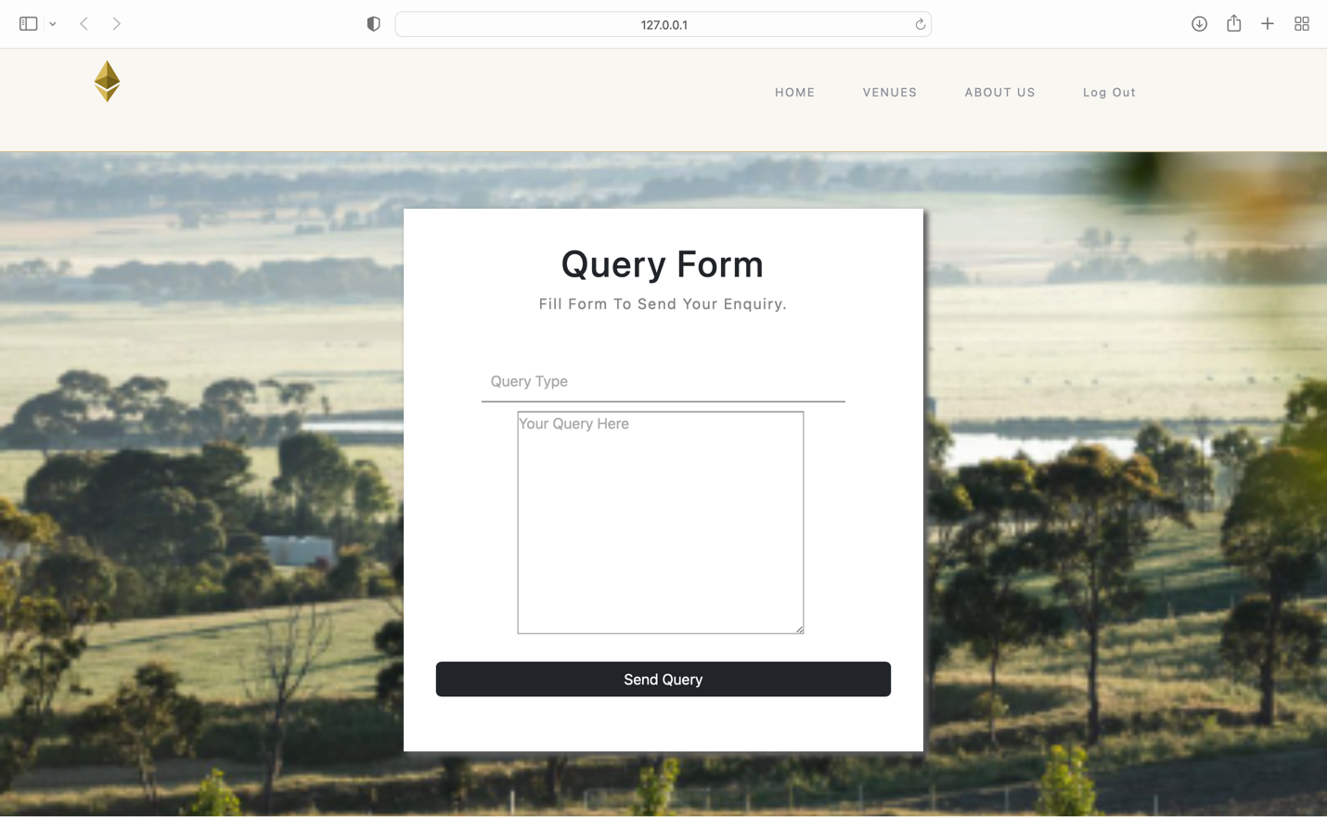

Figure 37: Query Form UI

# Section 5: Responses on the feedback from the lecturer

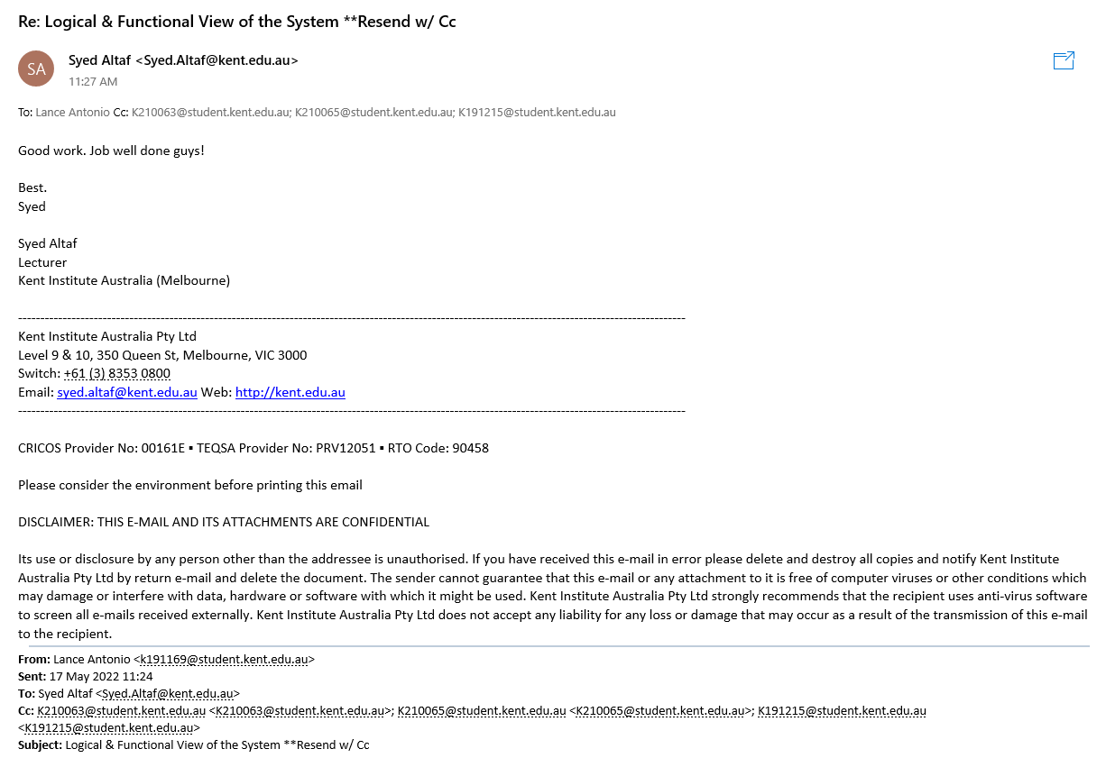

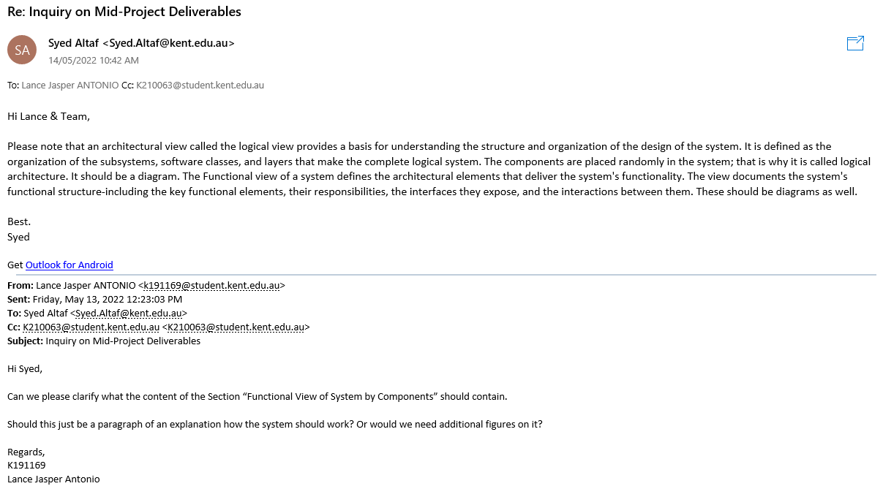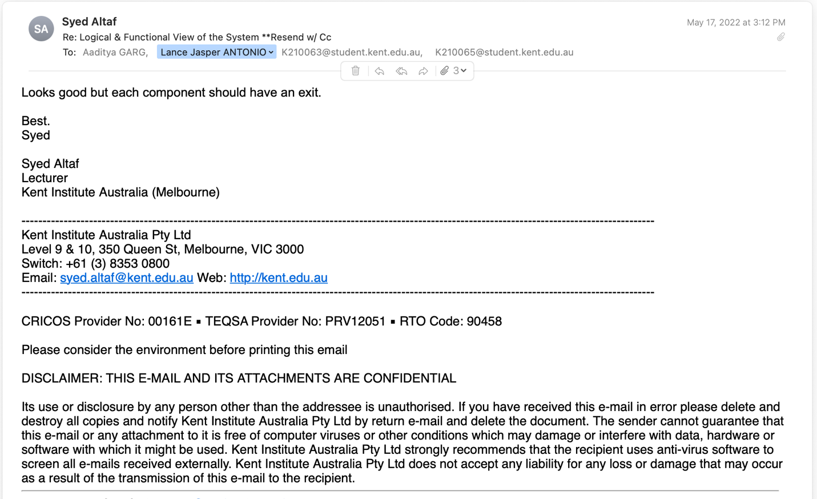

# Section 6: Appendix

Figure 1: Functional Requirements 2

Figure 2: Non-Functional Requirement 3

Figure 3: Software and Hardware Architecture Diagram 4

Figure 4: Logical View of the System 6

Figure 5: Registration 6

Figure 6: Home Page 7

Figure 7: Forgot Password 7

Figure 8: User Details 7

Figure 9: Event Booking 8

Figure 10: Manage Booking 8

Figure 11: User Query 9

Figure 12: User & Admin Dashboard 9

Figure 13: Active Events View 11

Figure 14: Admin User Query 12

Figure 15: Entity-Relationship Diagram 13

Figure 16: Event Master Entities 13

Figure 17: Event Entity 13

Figure 18:Event_Location Entity 13

Figure 19: Event-Schedule Entity 14

Figure 20: Event-Type Entity 14

Figure 21:Queries Entity 14

Figure 22: Users Entity 14

Figure 23:Home Page PC UI 15

Figure 24: Home Page Mobile UI 15

Figure 25: Forgot Password UI 16

Figure 26: Password Reset UI 16

Figure 27: Registration Page UI 17

Figure 28: User Dashboard UI 17

Figure 29: Admin Dashboard UI 18

Figure 30: Active Event View UI 18

Figure 31: Archive View UI 19

Figure 32: Users View UI 19

Figure 33: Queries View UI 20

Figure 34: Event Booking UI 20

Figure 35: Update User Details UI 21

Figure 36: Manage Event UI 21

Figure 37: Query Form UI 22

# Student Group Work Guidelines

## Purpose:

The following guideline is designed to help you organise and manage your group assessment task.

## Group work – Getting started:

Once your group is formed, the group work guideline can be useful to set up effective group work.

### 1 Introduction:

Spend some time getting to know each other, exchange preferred contact details.

### Outcomes:

Look at the assessment together and discuss:

* + What do we need to achieve / what is our outcome?
  + Break the assessment into individual tasks/steps from start to finish. For each task / step, discuss how long it would take.
  + Based on the tasks / steps and timing, create a timeline or diagram showing who will do what and when. You will need some mini‐deadlines so tasks are completed on time and in sequence.

### Student Group Work Guidelines and Individual Contribution Statement

Please remember that each group member receives a copy of the guideline and, once all responsibilities are assigned, each copy must be the same. This is important as it shows that all group members are aware of their responsibilities to the group. At the end of the completion of the Project Trimester a single hard‐copy to be submitted to Lecturer and a soft copy to be uploaded to Moodle link.

1. **What’s next?** Set up a schedule to meet – when/where/how often/how long? Meeting frequently will allow you to keep on track and to resolve any issues you may face over the assignment.

## Tips for group work:

1. Show respect to other members by
   * Communicating effectively – responding to messages, listening to others, allowing everyone the opportunity to speak and contribute.
   * Sticking to the schedule of meetings and tasks
2. If you have issues with group members not contributing, talk to your lecturer or ALS Co‐ordinator.
3. If you would like assistance with getting started, your ALS Co‐ordinator would be happy to help!



# STUDENT GROUP WORK GUIDELINE

|  |  |
| --- | --- |
| **Unit Title:** | CPRO306 |
| **Assessment Item Title** | Mid-Project Deliverables |
| **Assessment Due Date:** | Week 9 |
| **Group Members** | **1.** Lance Jasper Antonio |
|  | **2.** Aaditya Garg |
|  | **3.**Shreekrishna Sapkota |
|  | **4.**Binit Banjara |

|  |  |
| --- | --- |
| **#1 Student Name:** | Lance Jasper Antonio |
| **Tasks Responsible for:** | **1.** Document Structure |
|  | **2.** Documentation Section 1, 5, 2.5 |
|  | **3.** Home File, About Us File, Password Reset File, User Dashboard File |
|  | **4.** Overall Webpage layout |

|  |  |
| --- | --- |
| **#2 Student Name:** | Aaditya Garg |
| **Tasks Responsible for:** | **1.** Documentation Section 2.2 & 2.5 |
|  | **2.** Manage Booking File, User Details File, Registration File |

|  |  |
| --- | --- |
| **#3 Student Name:** | Shreekrishna Sapkota |
| **Tasks Responsible for:** | **1.** Database Structure |
|  | **2.** Database Implementation |
|  | **2.** Documentation Section 4, 2.5, & 3 |
|  | **3.** Admin Dashboard File, Archive View File, Event View File, Active Event View File |

|  |  |
| --- | --- |
| **#4 Student Name:** | Binit Banjara |
| **Tasks Responsible for:** | **1.** Documentation Section 3, 2.1, 2.4 & 2.5 |
|  | **2.** FR Component Allocation & Implementation |
|  | **3.** Customer View File, Event Booking File, Client Query File, Admin Query File |

## Individual Contribution Statement Form

**CONFIDENTIAL**

**Note: To be completed individually on completion of the project. A signed hard‐copy to be submitted to your Project Lecturer and a soft copy to be uploaded to the Moodle link.**

Team Name: B1 _- _ProIT

Lecturer Name: Syed Altaf

(Please respond to the relevant box below)

All work has been equally and fairly distributed and all team members have contributed more or less equally. I think it is fair that we all receive the same team mark for all tasks completed by the team. (Write brief notes in the box below)‐

All team-members are equally present in all meetings, responsive in group communication, and prompt in response when given feedback.

Work has **NOT** been equally distributed. I would suggest that the individual contribution for each task as listed could be summarised as follows:

|  |  |  |  |
| --- | --- | --- | --- |
| **Tasks** | **Team member Name** | **Individual Contribution % (Score out of 100 for each task)** | **Comments** |
|  | Member 1 |  |  |
| Member 2 |  |  |
| Member 3 |  |  |
| Member 4 |  |  |
| Member 5 |  |  |

### Note: Type in, then print and sign.

**Additional comments/notes‐ Add here (use additional pages if required)**

Signed: …Lance Jasper Antonio

Date: 22/05/2022